Doc Writer: Kamakshi Murali Doc Date: DEC 12, 2014.

Application or System Name

POST Cancel Rebill EMMA (BL_INT_POST_002)

General Overview

Business Requirements:

A new interface will be developed where ESB will pick up the Stale Data Export from the IEE file share and upload the contents of the file into SAP in the form of a web service call. The Stale Data export file would contain data of the interval edited in IEE after the billing determinant has been run for the periods edited. An EMMA case would be created with the details of the intervals edited to be worked upon by the Customer Billing team.

An interface will be developed to pick up the Stale Data Export files generated from IEE and process them in SAP. Emma cases will be generated with the changed interval values.

Technical Design:

INTERFACE: SI_CancelRebill_EMMA_In
The Stale Data Export file is picked up by ESB from the IEE folder and sent to SAP. The interface is inbound into SAP and processes the values found in the file into a Custom Table ZTBL_DEM_VAL_CHG. These values are then picked up the report program to create EMMA cases
REPORT: ZBLBL_CANCEL_REBILL_EMMA.

- Once the user executes the report two options are provided to the user on the selection screen.
a) Create EMMA Case.
b) Test Run.

- If the user selects Create EMMA Case option then the report would pick all the entries from the table ZTBL_DEM_VAL_CHG which are not processed i.e. it would pick all the files for which the value of the field ZPROC of the table is not equal to ‘X’.

- If any record is fetched from the table ZTBL_DEM_VAL_CHG then
It will fetch the installations based on the respective MDUS request id from the table EMDUSDRQHEAD, as the installations will be passed as the object key while creating the EMMA case.

- If the installations are found then the respective billing document number is fetched from the table ERCH based on the Contract.

- Once all the required Data is fetched then EMMA_MESSAGE will be created for those records through the method WRITE_EMMA_MESSAGE of the class ZCL_CS_AMI_UTILITY and

the field ZPROC of the table ZTBL_DEM_VAL_CHG will be updated to “X” which signifies that these records are processed.

- If EMMA Cases Check box and the TESt RUN checkbox
Option is selected then only the log messages are displayed using ALV and EMMA case will not be created and the table ZTBL_DEM_VAL_CHG also will not be updated.

- If create EMMA Cases Check box in the selection screen and execute the report. Emma case should be created and the processed flag should be updated in the table ZTBL_DEM_VAL_CHG.

- Based on the TVARVC values the old entries from the table ZTBL_DEM_VAL_CHG get deleted automatically on a periodic basis.

System Diagram
☐ Screen that’s presented to user
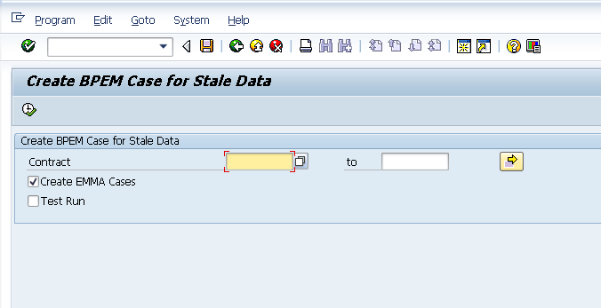

Technical Parts Inventory

-------Name------- | ----Description---- | -----Location----- | ----Environment---
ZBLBL_CANCEL_REBILL_EMMA | Program |  | ECD
ZCL_CS_AMI_UTILITY/ WRITE_EMMA_MESSAGE | Class/Method |  | ECD
ZTBL_DEM_VAL_CHG | Table |  | ECD
ZCL_SI_CANCEL_REBILL_EMMA_IN | Interface Class |  | ECD
ZCL_CANCEL_REBILL_EMMA | Processing Class |  | ECD

Dependent Parts Inventory
-------Name------- | ----Description--- | -----Location----- | ----Environment---

Security Roles and AD Group Needed to Run App

